Orwell, George (Eric Arthur Blair)

by Stephanie Boland

Summary

George Orwell is the pseudonym of Eric Arthur Blair. A writer, poet, journalist, broadcaster and critic, he is best known for his satirical novel *Animal Farm* (1945) and the dystopian *Nineteen Eighty-Four* (1949), both of which interrogate political systems (and the behaviour of the individual within them). The term ‘Orwellian’, meaning ‘following the logic of totalitarianism’, is primarily drawn from these novels. His long-form non-fiction works *Down and Out in Paris and London* (1933) and *The Road to Wigan Pier* (1937) exemplify his particular brand of social reportage, as well as being some of the most well-known works in the genre generally. Both document life among the poor: the former taking in London’s East End and the less prosperous parts of Paris, and the latter the working-class cities in England’s industrial North.

Orwell’s writing is characterised by straightforward, unembellished prose. His 1946 essay ‘Politics and the English Language’ draws a correlation between writing and ideology, lambasting ‘insincerity’ in contemporary written English. This unadorned style helps inform today’s consensus that Orwell was a profoundly common sense writer, committed to clarity in both language and argument. His literary criticism, political reportage, and polemic journalism have been frequently anthologised since his death, and are often held up as models in their respective genres.

Main Entry

George Orwell was born Eric Arthur Blair in June 1903 in Bihar, British India into a family he would later describe in *The Road to Wigan Pier* as ‘lower-upper-middle class’. He moved to England when a year old. His early education, at a school called St. Cyprian’s, was not pleasant; in what is now one of his most anthologised essays, ‘Such, Such Were the Joys’, Orwell attacks a school culture within which ‘virtue consisted in winning: it consisted in being bigger, stronger, han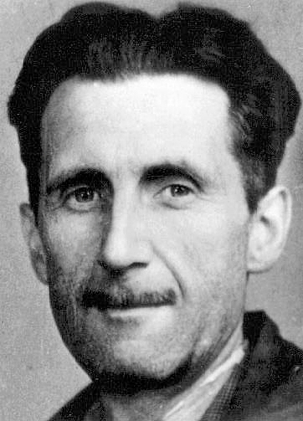dsomer, richer, more popular, more elegant, more unscrupulous than other people . .. Life was hierarchical and whatever happened was right’. In May 1917 he was admitted to Eton College as a King’s Scholar; while there, he would help produce the College magazine, *The Election Times,* although he later claimed he ‘did no work there and learned very little’.

After leaving school, Orwell joined the Imperial Police, part of the police administration in British India. He was posted to Burma in 1922 and spent five years there before a bout of dengue fever allowed his return to England, after which he resigned from the Police in order to write. His time in the country went on to inform work such as the 1934 *Burmese Days*, and iconic essays such as ‘A Hanging’ (1931) and ‘Shooting an Elephant’ (1936). The same year, Orwell moved to London. Here he began making trips into the East End, following in the footsteps of Jack London, whose study of the area, *The People of the Abyss* (1902), encouraged Orwell to explore the less prosperous parts of the city.

In 1928, Orwell moved to Paris and began to publish journalism, including articles in the political and literary journal *Monde*. His time in Paris, along with his reminiscences of the East End, formed the substance of his 1933 memoir *Down and Out in Paris and London*, an impassioned study of life in poverty.

Returning to England in December 1929, Orwell quickly became a regular contributor to other outlets such as the literary magazine *Adelphi*. Around this time the first version of *Down and Out*, then entitled *A Scullion’s Diary*, was rejected by English publisher Jonathan Cape and subsequently by T. S. Eliot, then editorial director at Faber & Faber. Orwell eventually took up work in a second hand bookshop in West London, gaining insight into a trade — which he termed ‘interesting enough’ — that he would later give to protagonist Gordon Comstock in the 1936 boarding house novel *Keep the Aspidistra Flying.* By 1935, Orwell’s fortunes were looking up: *A Clergyman’s Daughter* was published in March and the memoir *Burmese Days* in June, the latter earning a review from Orwell’s erstwhile schoolfriend Cyril Connolly in the *New Statesman* which put the pair back in contact.

In December of 1936, Orwell left for Spain to aid with the anti-Fascist effort in the Spanish Civil War. Once there, he headed to Barcelona and became involved with the Partido Obrero de Unifcación Marxista (POUM), or Workers’ Party of of Marxist Unification. Serving on the front line, Orwell was shot in the neck by a sniper. The bullet missed his main artery, and he recovered well; however, sent to a POUM sanatorium to recuperate, he was declared unfit for service and in 1937 he was sent back to England. Once home, his involvement with the war was the cause of some professional friction, with editors such as the *Statesman’s* Kingsley Martin cautious enough about his politics to reject work.

By March 1938, Orwell was hospitalised again with what was thought to be tuberculosis. When war broke out, he put himself forward to assist in the war effort but his health prevented much activity. Instead, he wrote, working as a critic for popular literary magazines like *The Listener*, *Time and Tide* and the *New Adelphi*. In 1940, Connolly established *Hori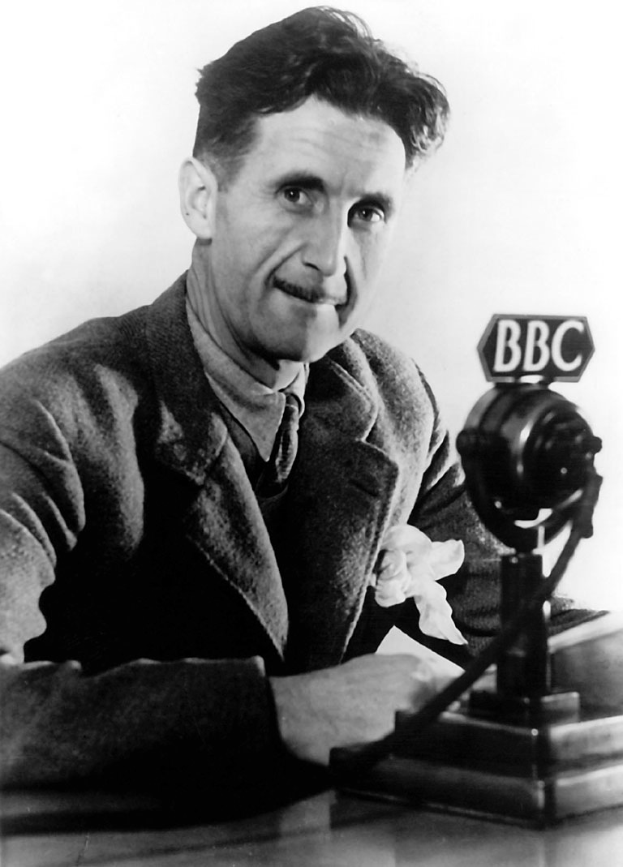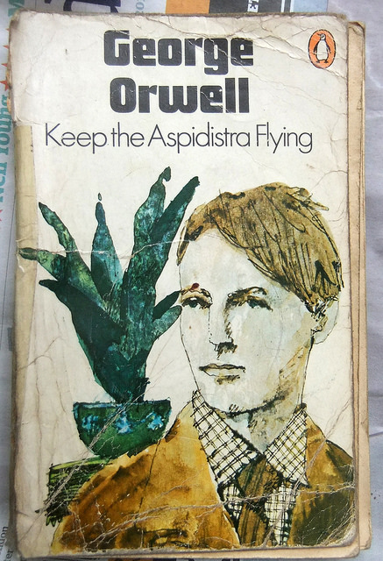zon*, providing Orwell with another outlet. In the same year, Orwell joined the Home Guard and began theorising a socialist agenda for the organisation, developing his political vision while continuing to write for various magazines and periodicals, including the American left-leaning *Partisan Review* and the English *Tribune*, of which he was to become literary editor in 1942. He also gained employment with the BBC’s Eastern Service and oversaw broadcasts to India aimed at countering Nazi propaganda; around this time he began work on *Animal Farm*.

The next few years were to prove tumultuous. In 1944, Orwell and his wife Eileen (née O’Shaughnessy) adopted a child, Richard Horatio Blair. Orwell was offered an overseas post reporting on the war for the British weekly newspaper the *Observer.* While he was away, his wife Eileen died during a hysterectomy. Orwell returned to London in July of 1945 to cover the UK General Election. In August, *Animal Farm* was published, receiving worldwide critical acclaim. Orwell remained in England, writing articles and essays, until the death of his sister in May 1946. Shortly after, he moved to the Isle of Jura, off the coast of Scotland, where he lived intermittently while working in *Nineteen Eighty-Four*.

After suffering what was again diagnosed as tuberculosis, Orwell was moved to a sanatorium in Gloucestershire. Here he was visited by Celia Kirwan, a worker at the Foreign Office who had been tasked with helping the Labour government publish anti-communist propaganda. Orwell handed over what has since become a notorious list of writers and other public figures he considered unsuitable due to suspected communist sympathies, including Kingsley Martin, historian E. H. Carr, Scottish poet Hugh MacDiarmid and the actor Charlie Chaplin. In July 1949, *Nineteen Eighty-Four* was published to great critical acclaim. Orwell, however, did not live long enough to enjoy his success: he died in January 1950 after an artery burst in his lungs. He was 46.

Modernism

Orwell was a contemporary of many modernist writers, and his relationship to literary modernism is one of influence and exchange rather than stylistic similarity. Although his self-consciously straightforward prose is far from that which characterises modernist experimentation, several key modernist authors were cited as his favourites, including James Joyce, T. S. Eliot and D. H. Lawrence. Many of the venues Orwell published in also published work by writers in the modernist canon: the *New Statesman*, for instance, ran work by Elizabeth Bowen; *Time and Tide* published, among others, Virginia Woolf, Storm Jameson and Rebecca West.

It is not surprising, therefore, that critics such as Michael Levenson have argued that ‘Orwell composed [his] books . . . with an intense consciousness that he was writing after the heady days of modernism and beneath its shadow’.[1] Various arguments have also been made for Orwell’s texts being modernist in character. Patricia Rae, to give just one relatively arbtritary example, has suggested that *The Road to Wigan Pier* is ‘modernist anthropology’.[2]

‘Inside the Whale’ (1940) is Orwell’s most comprehensive engagement with literary modernism. A review essay on Henry Miller’s *The Tropic of Cancer*, the piece also considers trends in 1920s and 1930s literature, identifying a ‘movement’ contai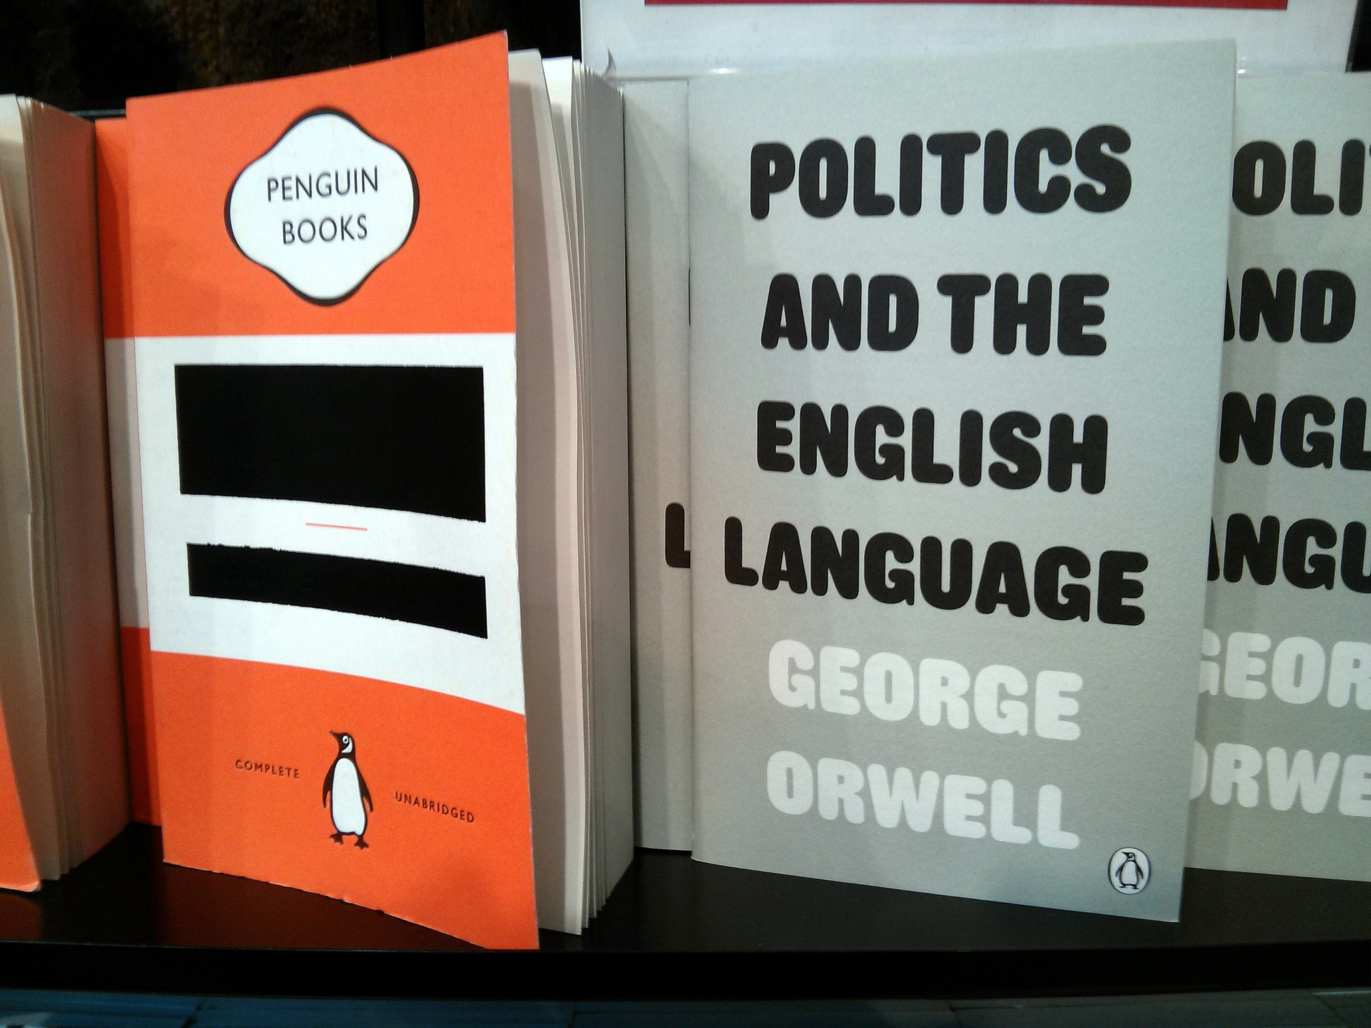ning Eliot, Ezra Pound, Joyce, Wyndham Lewis, Aldous Huxley and others. Although Orwell notes rifts within the movement, he also identifies a ‘certain temperamental similarity’ in what he called the ‘Joyce-Eliot group’. He praises certain aspects of modernist literature, for instance Joyce’s skill in representing what is ‘commonplace’, but is wary of what he sees as an apolitical tendency in the 1920s intelligentsia, and eschews any identification with them.

Reception

Orwell’s politics have been a matter of some dispute. Although the incorporation of *Animal Farm* and *Nineteen Eighty-Four* into the British school curriculum means that Orwell is often encountered as a politically-charged novelist before he is read as a polemicist or journalist, his personal politics are more complex than a reading of either novel would reveal. (It is worth noting that both were written after Orwell became dissatisfied with Marxist socialism, and represent a certain pessimism with regard to political regimes).

In his own words, Orwell was ‘in sentiment definitely ‘Left’’, but believed ‘that a writer can only remain honest if he keeps free of party labels’. He was wary of political cant and careerist politicians. Orwell joined the Independent Labour Party in 1938, praising their Socialist principles in *The Lion and the Unicorn*, but would later leave. His refusal to commit to a political group means Orwell has been claimed by the right wing as a writer who exposes the true nature of Socialism in his critique of the Stalinist regime — in ‘Inside the whale’, he writes that the ‘USSR is in alliance with France, a capitalist-imperialist country’ — and by the left as a critic of the inequality brokered by empire-building and capitalism.

**Bibliography**

By their nature, Orwell’s works are well-suited to anthologies, and dozens have been produced since his death. There is therefore some overlap of content in the volumes given below.

Collected Works

*The Complete Essays, Journalism and Letters of George Orwell*

Four volumes

*The Complete Works of George Orwell*

Twenty-volume series

*Orwell: The Complete Works* (1998)

Includes 26 poems written by or ascribed to Orwell

*The Complete Novels* (1976)

*Essays* (2002)

*Lost Orwell: Being a Supplement to The Complete Works of George Orwell* (2006)

Includes letters, an obituary of HG Wells and the aforementioned, notorious ‘Orwell’s list’

Novels and book-length non-fiction

*Down and Out in Paris and London* (1933)

*Burmese Days* (1934)

*A Clergyman’s Daughter* (1935)

*Keep the Aspidistra Flying* (1936)

*The Road to Wigan Pier* (1937)

*Homage to Catalonia* (1938)

*Coming Up for Air* (1939)

*Animal Farm* (1945)

*Nineteen Eighty-Four* (1949)

Essay Collections Published in Orwell’s Lifetime

*Inside the Whale and Other Essays* (1940)

*Critical Essays (1946)*

*Shooting an Elephant and Other Essays* (1950)

*England Your England and Other Essays* (1953)

Selected Collections Published Subsequently

*Decline of the English Murder and Other Essays* (1965)

*All Art is Propoganda: Critical Essays* (2008)

*Facing Unpleasant Facts: Narrative Essays* (2008)

As part of the Penguin ‘Great Ideas’ series:

*Why I Write* *(2005)*

*Books vs. Cigarettes* (2008)

*Decline of the English Murder* (2009)

*Some Thoughts on the Common Toad* (2010)

*Radio material*

Much of this is held at the BBC, but two collections also exist:

*Orwell: The War Broadcasts* (1985)

*Orwell: The War Commentaries* (1985)

*Adaptations*

Orwell’s novels have been adopted multiple times for film and television. A short list is given here if only in recognition of his place on so many curricula.

*Animal Farm* (films 1954; 1999)

*1984* (film 1956)

*Nineteen Eighty-Four* (film, 1984; television programme, 1953)

*Keep the Aspidistra Flying* (film 1997)

*1984* (opera, 2005)

Further reading

*The Cambridge Companion to George Orwell* (2007)

*George Orwell* (1998; casebook from Macmillan Press)

*Orwell’s Politics* by John Newsinger (2002)

*George Orwell: The Politics of Literary Reputation* (2001)

*Why Orwell Matters* by Christopher Hitchens (2002)

Bibliography

Orwell requested that no biography be written of his life. This has not been heeded, and the list below is only indicative.

*George Orwell: A Life* by Bernard Crick (1992)

*George Orwell: A Political Life* by Stephen Ingle (1993)

*Orwell: The Life* by DJ Taylor (2003)

*George Orwell* by Gordon Bowker (2003)

Photos:

1. The photograph from Orwell’s press card. Photo: Branch of National Union of Journalists/Wikipedia Commons

2. A 1963 Penguin cover of Orwell’s novel Keep the Aspidistra Flying. Photo: Gwydion M Williams/Flickr

3. George Orwell at the BBC in 1940. Photo: Penguin Books India

4. A vintage Penguin re-issue of 1984, with ‘censored’ cover, shown next to Politics and the English Language at Foyle’s book shop, London. Photo: Cory Doctorow/Flickr

1. Michael Levenson, ‘The fictional realist: novels of the 1930s’, *The Cambridge Companion to George Orwell,* (Cambridge: Cambridge University Press, 2007), p.59.
2. Patricia Rae, ‘*The Road to Wigan Pier* as modernist anthropology’, *George Orwell*, Ed Howard Bloom (New York: Infobase, 2007), pp. 63-96.